The Cannon Book was migrated to Microsoft Word from a hard copy manuscript via a scanner and an OCR program to convert the scanned image to editable text.

This continues to be a work in progress since there is so much additional information that has come to light. The first five generations fill about half of the original book. As time permits I will continue to scan and correct the text.

There is a feature of Microsoft Word that allows me to put links into the document so that you can jump immediately from child to parent of parent to child by just clicking on the link. This feature is a little irritating with the newer releases since you will be quizzed each time you use one of the links about your desire to save the document.

In the below example the names in the table of contents are established as links. When a TOC entry is clicked, you are taken to that page immediately. You can return to the beginning of the document by pressing cntl+home.

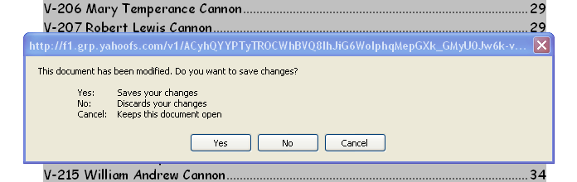

I am looking for a way to minimize this 'feature'. There is apparently no way around this. I have sent a request for a program modification to Microsoft. I have done this sort of thing in the past with favorable results. The favorable results (if Microsoft agrees) will take some time though, months at least.

I have broken to book into 'two volumes' to allow a quicker download for those of you who do not have a high speed link.

Maybe that is not small enough? Maybe I should put it back into a single volume?

Send me a note.

Please enjoy The Cannon Book and feel free to comment.

Dennis Fogleman

See: http://worldconnect.rootsweb.com/cgi-bin/igm.cgi?db=dfog for the GEDCOM uploaded to Rootsweb.

